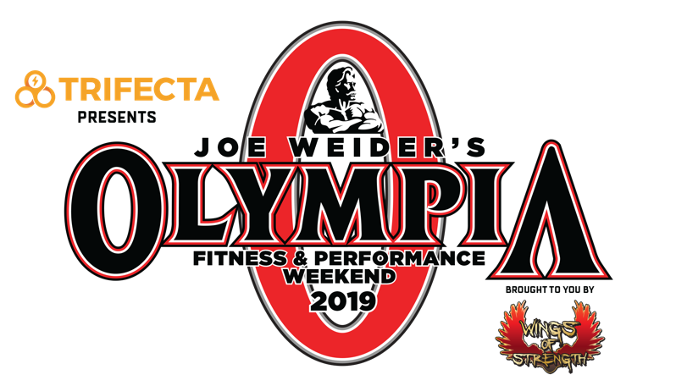

*All expo events require paid expo entry*

*Admission to Olympia Finals requires Arena Ticket*

*Visit Box Office or MrOlympia.com*

**TUESDAY, SEPTEMBER 10 – ORLEANS HOTEL SALON G**

12:00 PM Amateur Olympia Athlete Registration (All Divisions) – Hotel Salon G

**WEDNESDAY , SEPTEMBER 11 – ORLEANS HOTEL SHOWROOM**

8:00 AM Amateur Olympia Judging & Finals – Hotel Showroom

* Women’s Physique
* Figure
* Bikini

**THURSDAY , SEPTEMBER 12 – ORLEANS HOTEL SHOWROOM**

8:00 AM Amateur Olympia Judging & Finals – Hotel Showroom

* Bodybuilding
* Classic Physique
* Men’s Physique

**THURSDAY, SEPTEMBER 12 – ORLEANS ARENA**

12:00 PM Olympia Press Conference – Orleans Arena

7:00 PM Meet the Olympians **Early Entry** (VIPs & Platinum Members) – Orleans Arena

8:00 PM Meet the Olympians (Open to the Public) – Orleans Arena

**FRIDAY, SEPTEMBER 13 – LAS VEGAS CONVENTION CENTER (SOUTH HALL)**

7:30 AM Zumba® Basic 1 Instructor Training (Room #102)

8:00 AM Early Expo Entry for VIP Ticket Holders & Platinum Members

9:00 AM Expo Admission for Early Entry Passholders

10:00 AM Olympia Expo Doors Open for Everyone

10:00 AM **IFBB Professional League Pre-Judging (Expo Stage)**

*(Reserved seating for VIPs & Platinum members only)*

Fitness Olympia Pre-Judging

212 Olympia Pre-Judging

Figure Olympia Pre-Judging

Women’s Physique Olympia Pre-Judging

10:00 AM Muay Thai

Sanda

Jiu Jitsu Grappling

Karate

USA Boxing

Kettle Ball Challenge

Kickboxing

Strength Sports – Ultimate Series

Kung Fu

Pro Powerlifting Championships

Sombo

Tae Kwon Do

PERFORMIX Pro Skateboarding Demos

Wrestling

Strongman Challenge

Fit Fashion Show

The Spartan Race Short Course

10:00 AM Zumba® Cardio Blast (Heart Rate Zone #153)

10:45 AM STRONG®30 (Heart Rate Zone #153)

11:30 AM Zumba® Fitness Party (Heart Rate Zone #153)

12:15 PM STRONG®30 (Heart Rate Zone #153)

1:00 PM Zumba® Cardio Blast (Heart Rate Zone #153)

1:45 PM STRONG®30 (Heart Rate Zone #153)

2:00 PM **Wings of Strength Female Bodybuilding Posing Exhibition (Expo Stage)**

2:30 PM Zumba® Fitness Party (Heart Rate Zone #153)

3:15 PM STRONG®30 (Heart Rate Zone #153)

3:30 PM **Ronnie Coleman Book Release Event (Expo Stage)**

4:00 PM Zumba® Cardio Blast (Heart Rate Zone #153)

**FRIDAY, SEPTEMBER 13 – ORLEANS ARENA**

3:00 PM Private Backstage Tour & Photo Opp (Gold VIP & Platinum Members Only)

7:00 PM Olympia Arena Finals: 212, Fitness, Figure & Women’s Physique.

Plus: Mr. Olympia Pre-Judging

**SATURDAY, SEPTEMBER 14 – LAS VEGAS CONVENTION CENTER (SOUTH HALL)**

7:30 AM Strong by Zumba® Instructor Training (Room #102)

8:00 AM Early Expo Entry for VIP Ticket Holders & Platinum Members

9:00 AM Expo Admission for Early Entry Passholders

10:00 AM Olympia Expo Doors Open for Everyone

10:00 AM **IFBB Professional League Pre-Judging (Expo Stage)**

*(Reserve seating for VIPs & Platinum members only)*

Bikini Olympia Pre-Judging

Men’s Physique Olympia Pre-Judging

Classic Physique Olympia Pre-Judging

10:00 AM Sanda

Strongman Challenge

USA Boxing

Jiu Jitsu Grappling

Karate

Kettle Bell Challenge

Kickboxing

Olympia Strength Sports – Ultimate Series

Kung Fu

Pro Powerlifting Championships

Sombo

Tae Kwon Do

Wrestling

Muay Thai

PERFORMIX Pro Skateboarding Demos

Fit Fashion Show

Spartan Race Short Course

10:00 AM Zumba® Cardio Blast (Heart Rate Zone #153)

10:45 AM STRONG®30 (Heart Rate Zone Stage #153)

11:30 AM Zumba® Fitness Party (Heart Rate Zone #109)

11:45 AM Zumba® (Heart Rate Zone #121)

12:30 PM **Wheelchair Olympia Bodybuilding Championship (Expo Stage)**

12:45 PM STRONG®30 (Heart Rate Zone #153)

1:00 PM Zumba® Cardio Blast (Heart Rate Zone #153)

1:45 AM STRONG®30 (Heart Rate Zone #153)

2:00 PM PERFORMIX Pro Skateboarding Showdown (Booth #1375)

2:00 PM **Celebrating the Greatest Female Bodybuilders of All-Time (Expo Stage)**

2:30 PM Zumba® Fitness Party (Heart Rate Zone #153)

3:15 PM STRONG®30 (Heart Rate Zone #153)

3:00 PM **OG Pole Fitness (Expo Stage)**

4:00 PM Zumba® Cardio Blast (Heart Rate Zone #153)

**SATURDAY, SEPTEMBER 14 – ORLEANS ARENA & HOTEL**

7:00 PM Olympia Arena Finals: Mr. Olympia, Bikini, Men’s Physique & Classic Physique

11:00 PM Olympia Victory Gala (Gold & Silver VIPs only) – Mardi Gras Ballroom in Hotel

**SUNDAY, SEPTEMBER 15 – ORLEANS HOTEL**

11:00 AM Superstar Seminar – Mardi Gras Ballroom`